# Amrita School of Engineering, Amritapuri Campus.

**19CSE101: Computer Systems Essentials LAB SHEET 2-RDBMS**

# PostgreSql – Copy & Select Query familiarization

1. Create the table StudentDetails with attributes RollNo, Name, Gender, Branch, District, State,HorD, AdmissionYear, CGPA, Batch.

**Hint: Refer the CSV file given and decide the data type required for each attribute.**

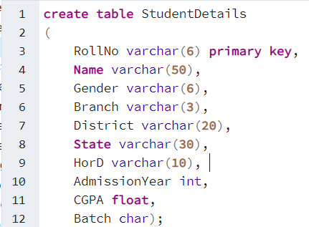



1. Import data to the table StudentDetails from the csv file given.

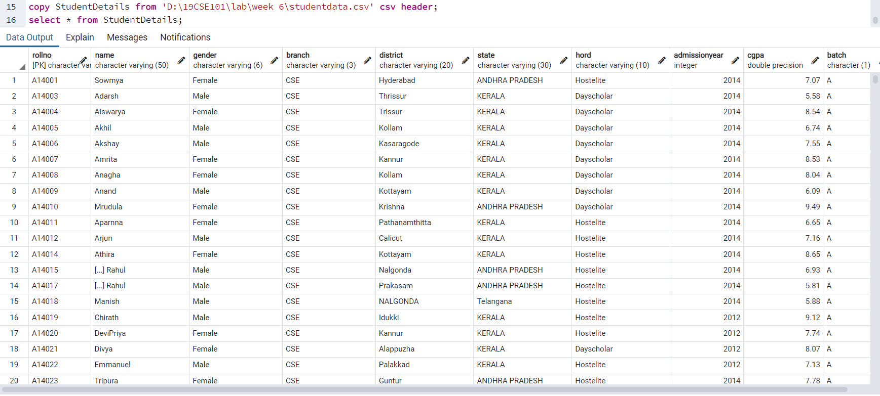

3. Fill in the blanks and Write the queries used to find the answer?

a) Name of the student with RollNo A14062 is _______Shiv__________

b) The total number of students from Trivandrum is _______3_________

c) The number of students who belong to the state ANDHRA PRADESH is

_______138_______

d) Number of students who got admission in ME in the year 2014 is ______10_____

e) Number of students in CSE A batch with admission year as 2014 is ____22_____

1. Fill the given tables and Write the corresponding query.

|  |  |  |  |  |
| --- | --- | --- | --- | --- |
| **Year of Admission** | **No. of students in CSE** | **No. of students in ME** | **No. of students in EEE** | **No. of students in ECE** |
| **2005** | 0 | 0 | 0 | 24 |
| **2012** | 4 | 49 | 32 | 11 |
| **2010** | 13 | 0 | 27 | 19 |
| **2008** | 37 | 12 | 0 | 0 |

|  |  |  |
| --- | --- | --- |
|  | **CSE** | **ME** |
| **No.of Boys** | 101 | 126 |
| **No. of Girls** | 39 | 1 |
| **No. of Hostelites** | 73 | 68 |
| **No.of Dayscholars** | 67 | 59 |
|  |  |  |

|  |  |  |  |  |
| --- | --- | --- | --- | --- |
|  | **CSE** | **ME** | **EEE** | **ECE** |
| **No: of 2014 admission students having CGPA greater than 9** | 3 | 1 | 3 | 3 |
| **No.of hostelite students having CGPA less than 6** | 13 | 10 | 9 | 13 |
| **No. of day scholar students having CGPA greater than 8** | 31 | 27 | 9 | 15 |
| **No. of female students having CGPA between 5 and 7** | 6 | 0 | 3 | 15 |

|  |  |  |  |  |
| --- | --- | --- | --- | --- |
|  | **CSE, 2014**  **Admission** | **ME, 2014**  **Admission** | **EEE, 2014**  **Admission** | **ECE, 2014**  **Admission** |
| **Average CGPA** | 7.522 | 7.198 | 7.528 | 7.456 |
| **Average CGPA of Girls** | 8.282 | 0 | 7.406 | 7.68 |
| **Average CGPA of Boys** | 6.825 | 7.198 | 7.554 | 7.232 |
| **Average CGPA of Hostelites** | 7.112 | 7.663 | 7.474 | 7.665 |
| **Average CGPA of Dayscholars** | 7.898 | 6.5 | 7.85 | 6.273 |

|  |  |  |  |  |
| --- | --- | --- | --- | --- |
|  | **CSE, 2014**  **Admission** | **ME, 2014**  **Admission** | **EEE, 2014**  **Admission** | **ECE, 2014**  **Admission** |
| **Max CGPA** | 9.5 | 9.64 | 9.49 | 9.64 |
| **Min CGPA** | 4.03 | 5.39 | 4.03 | 4,03 |
| **Max CGPA of Hostelelite Boys** | 9.5 | 9.64 | 9.49 | 9.64 |
| **Min CGPA of Dayscholar Boys from kollam district** | 6.74 | 6.63 | 8.58 | 0 |
| **Max CGPA of Hostellite girls** | 8.65 | 0 | 9.12 | 9.64 |
| **Max CGPA of Hostellite students from BIHAR** | 9.5 | 0 | 0 | 5.39 |
| **Min CGPA of students from Trivandrum district of KERALA** | 4.03 | 0 | 0 | 0 |